**President Sam Houston**

**RULES:** Practical Shooting Handbook, Latest Edition **COURSE DESIGNER:** Ike Starnes

|  |  |
| --- | --- |
| **START POSITION: See written stage briefings.** | |
| **STAGE PROCEDURE**  Engage targets from within the shooting area. | **SCORING**  **SCORING:** See WSB  **TARGETS:** See WSB  **SCORED HITS:** See WSB  **START-STOP:**  Audible - Last shot  **PENALTIES:** Mike -10, NS -10, Procedural -10 |

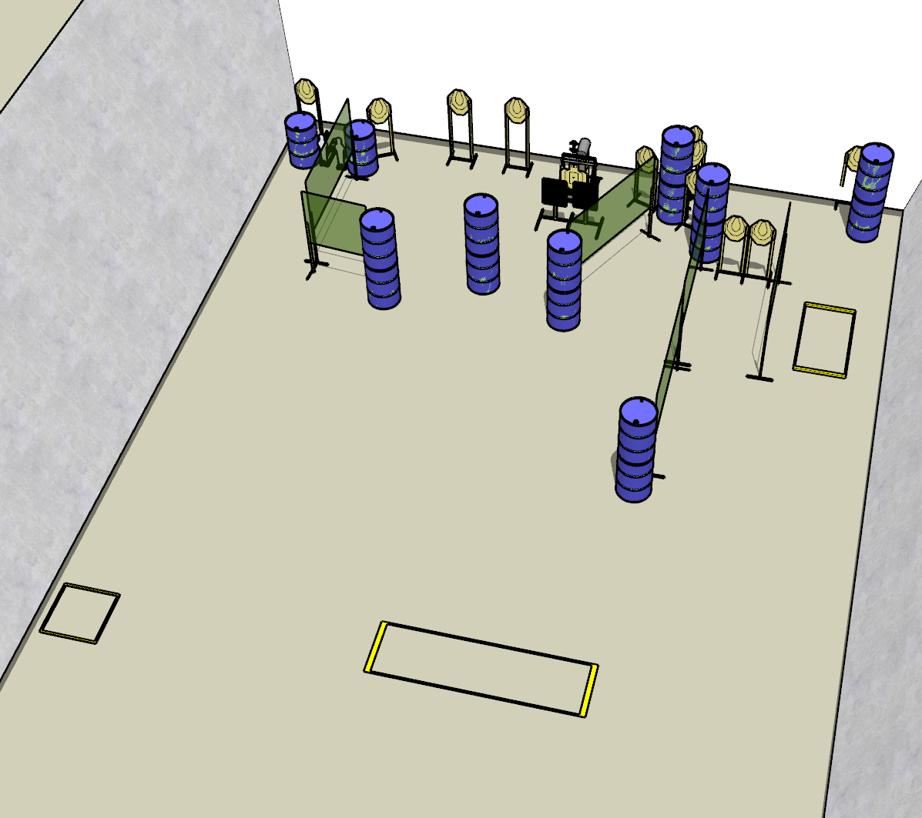

**Written Stage Briefings:**

**Stage 1 –** is a 26-round, 130 point, Comstock Long Course. There are 12 cardboard targets and 2 steel targets. The best 2 hits per cardboard target will be scored. The steel must fall to score.

**Handgun start position** is both feet inside the left shooting box, wrists below belt. The handgun is **loaded** and holstered.

**PCC start position** is both feet inside the left shooting box. PCC is **loaded** with buttstock on belt.

On the audible start signal, engage targets from within the shooting area.

The bobber target is activated by the right popper and is visible at rest.

**Stage 2 –** is a 28-round, 140 point, Virgina Count Medium Course. There are 12 cardboard targets. The best 2 hit per cardboard target will be scored, except for the bobber target, which will score best 4 hits.

**Handgun start position** is toes of both feet on rear of center shooting box, wrists below belt. The handgun is **unloaded** and holstered.

**PCC start position** is toes of both feet on rear of center shooting box. PCC is **unloaded** and held in both hands with buttstock on belt.

On the audible start signal, engage targets from within the shooting area.

The bobber target is activated by the right popper and is visible at rest.

**Stage 3 –** is a 22-round, 110 point, Comstock Long Course. There are 10 cardboard targets. The best 2 hits per cardboard target will be scored

**Handgun start position** is both feet inside the right shooting box, wrists above shoulders. The handgun is **loaded** and holstered.

**PCC start position** is both feet inside the right shooting box. PCC is **loaded** with buttstock on belt, strong hand wrist above shoulders.

On the audible start signal, engage targets from within the shooting area.